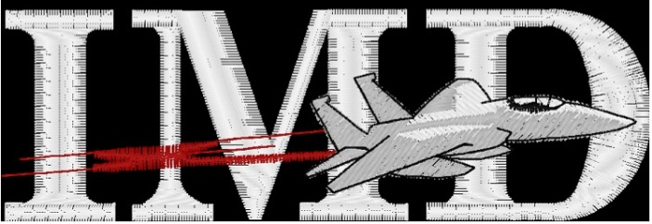

*Integrated Machine & Design*

*411 Hwy 199 West, Springtown, Texas 76082*

*(817) 220-8715 (817) 220-8512*

*Fax (817) 220-8531*

**Application for Employment**

Pre-Employment Questionnaire

Equal opportunity employer

**PERSONAL INFORMATION DATE__________________________**

|  |  |
| --- | --- |
| Name (Last name first) | Social Security No. |
| Present address | City, State, Zip Code |
| Phone No. | Secondary Phone No. |

**EMPLOYMENT DESIRED**

|  |  |  |
| --- | --- | --- |
| Position | Date you can start | Salary desired |
| Are you currently employed? | If so, where? | Are you legally authorized to work in the U.S.? |

**EDUCATION HISTORY**

|  |  |  |  |  |
| --- | --- | --- | --- | --- |
|  | Name & Location of school | Years attended | Did you Graduate? | relevant Subjects Studied |
| High school |  |  |  |  |
| college |  |  |  |  |
| Trade or business school |  |  |  |  |

**GENERAL INFORMATION**

|  |
| --- |
| Subject of Special study |
| Special training |
| Special Skills |
| U.S. Military or naval service? If so, please list rank |

**FORMER EMPLOYERS** (LIST BELOW LAST FOUR EMPLOYERS, STARTING WITH MOST RECENT)

|  |  |  |  |  |  |
| --- | --- | --- | --- | --- | --- |
| Date  Month & Year | Name, Address &  Phone No. of Employer | | Salary | Position | Reason for leaving |
| From: | |  |  |  |  |
| To: | |  |  |  |  |
| From: | |  |  |  |  |
| To: | |  |  |  |  |
| From: | |  |  |  |  |
| To: | |  |  |  |  |
| From: | |  |  |  |  |
| To: | |  |  |  |  |

**CRIMINAL HISTORY**

|  |
| --- |
| Do you have any criminal arrests or Convictions on your record? |
| Date of arrest/conviction |
| If yes, Please explain |

**REFERENCES** (PLEASE LIST THREE INDIVIDUALS NOT RELATED TO YOU, WHOM YOU HAVE KNOWN AT LEAST 1 YEAR)

|  |  |  |  |
| --- | --- | --- | --- |
| NAME | Contact Phone No. | Place of business & TITLE | Years known |
|  |  |  |  |
|  |  |  |  |
|  |  |  |  |

**AUTHORIZATION**

“I certify that the facts contained in this application are true and complete to the best of my knowledge and understand that, if employed, falsified statements on this application shall be ground for dismissal. I authorize investigations of all statements contained herein and the references and employers listed above to give you any and all information concerning my previous employment and any pertinent information they may have, personal or otherwise, and release the company from all liability for any damage that may result from the utilization of such information. I also understand and agree that no representative of the company has any authority to enter into any agreement for employment unless it is in writing and signed by the President of Integrated Machine & Design. This waiver does not permit the release or use of disability-related or medical information in a manner prohibited by the Americans with Disabilities Act and other relevant federal and state laws.”

____________________________ ___________________________ ________________________

SIGNATURE PRINTED NAME DATE